W7 PRACTICE
Modals & Forms

 Learning objectives
- Display a list of items using a ListView and ListTile widgets.
- Open a modal bottom sheet to create a new item.
- Collect user input through TextField widgets.
- Create and validate a new item from the entered data.
- Add the newly created item to the list and update the main screen dynamically.

How to submit?
- Push your final code on your GitHub repository
- Then attach the GitHub path to the MS Team assignment and turn it in

 Before practice, to be prepared!
Read the following documentation to be ready for this practice:

Use a List View
Render widgets conditionally

Lifting state up
Work with outlined buttons

EX 1 – Handle the Textfield input
For this bonus exercise, you can continue last week exercise 2 code and make the temperature converter working properly.

TIP
- 2 ways to get a textfield value (using a state or a controller)

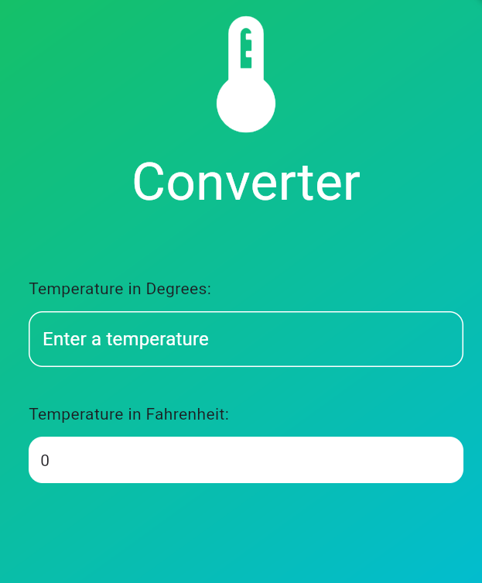

EX 2 – The Grocery App
⚠️ This exercise is graded, take time to develop it properly!

Develop an app to view, add and remove grocery items.

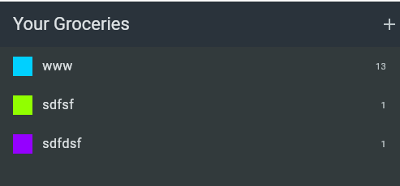

Application structure
The application is structured around 3 layers: DATA > MODEL > UI

data | Layer to provide the data (the list of grocery items)
model | Layer to define the structure of the data
ui/screens | We group screens on ui/screens folder
ui/widgets | Reusable widgets (buttons…)

Application model
The application model is composed of grocery items. Each item has its specific type.

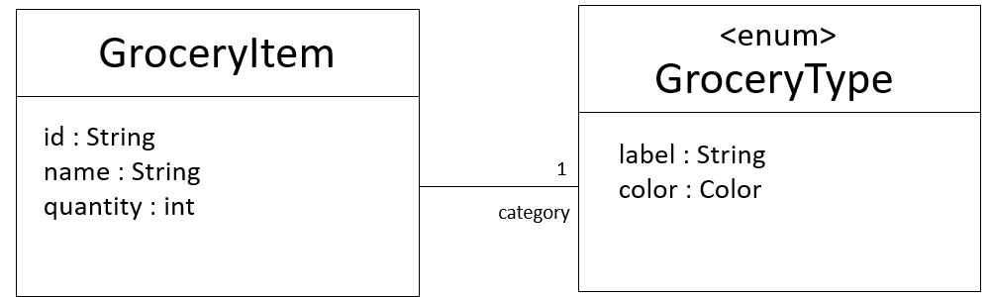

1 – Display the list of grocery items

At startup, the application opens the GroceryScreen.

We want to display the list of grocery items in the groceries screen as follows:
- Each grocery item shall be displayed with its name, quantity and the color related to its type

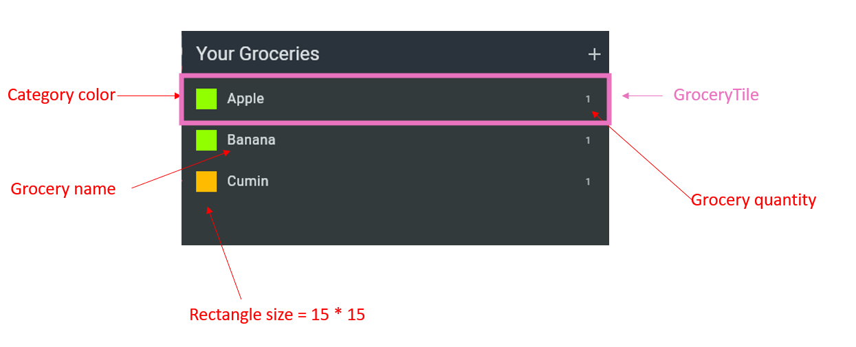

TODOS

- A mock list of grocery items is provided by the following class:
/data/mock_grocery_data.dart

- Use a List Builder to loop on grocery items

- Create a new stateless widget : GroceryItemTile
- Use a ListTile widget to layout the elements

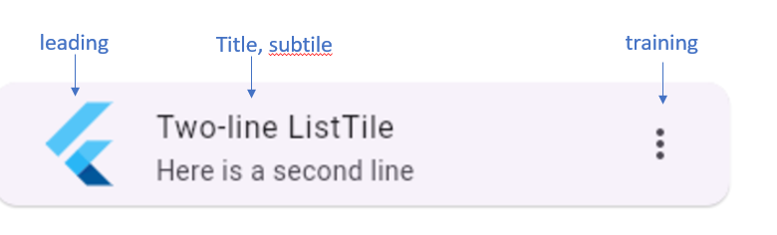

2 – Display the Grocery Item Form

When clicking on the plus button, we want to switch to the Grocery Form to create a new item.

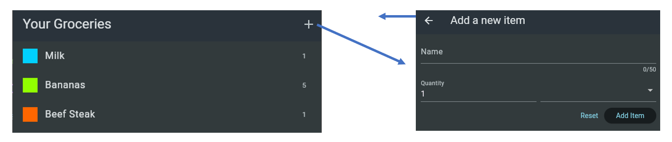

TODOS

- Add a + button on the main screen (GroceryScreen) app bar

- When button is pressed, open a bottom modal

- Create a new stateful widget : GroceryItemForm

The form shall be composed of 2 text fields:
- Name of the grocery item
- Quantity (number only)

⚠️ For now we don’t select the grocery type, we assume it’s always food

The form shall be composed of 2 buttons:
- Cancel button
- Add item button

3 – Add the created item to the grocery list

When clicking on the Add item button, we want to switch back to the Grocery Form to create a new item.
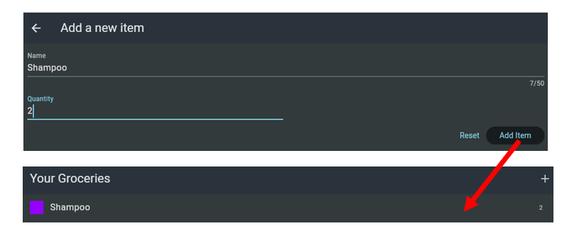

TODOS

When clicking on the Add item button:

  - Create a new Grocery Item
  - Pass the created item to the previous screen, using, using the pop() return value
  - On previous screen, get the created item, using an await push

  - Update the list of groceries

